**LAB CYCLE-1**

**Output:**

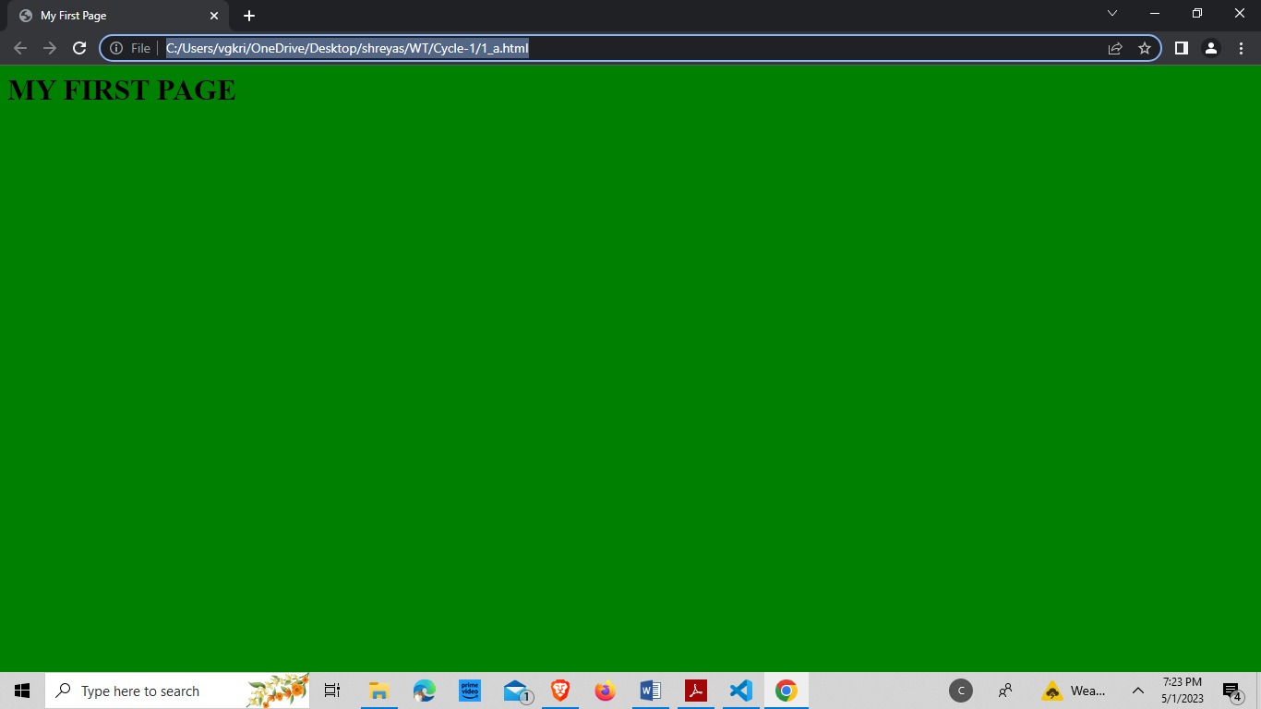

1. **Create a web page having the background in green and title “My First Page”.**

**Source -Code:**

<html>

<head>

<title>My First Page</title>

</head>

<body bgcolor="green">

<h1>MY FIRST PAGE</h1>

</body>

</html>

**Output:**

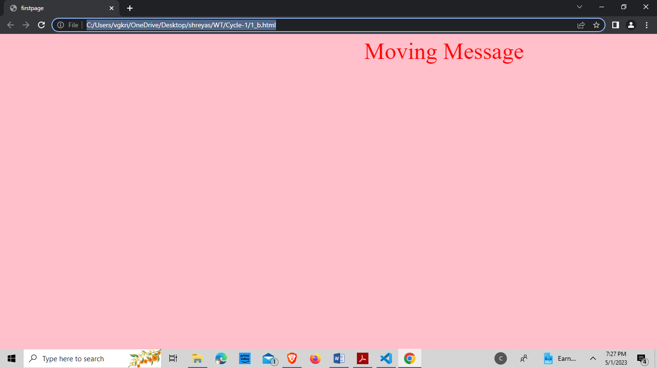

1. **Create a web page of pink color and display a moving message in red color.**

**Source-Code:**

<html>

<head>

<title>firstpage</title>

</head>

<body bgcolor="pink">

<font color="red" size="40">

<marquee>Moving Message</marquee>

</font>

</body>

</html>

**Output:**

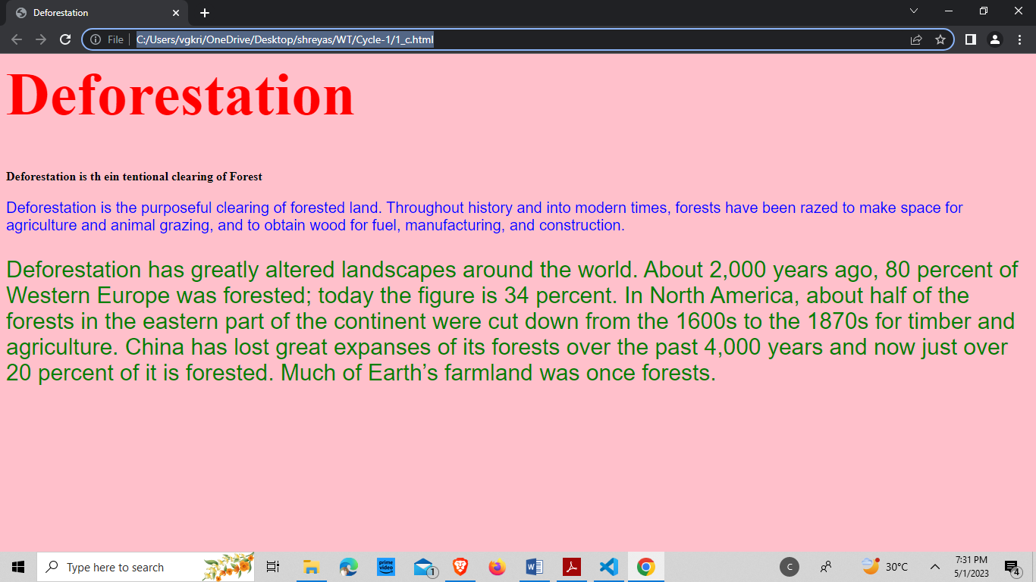

1. **Design a web page containing text, in form of paragraphs giving suitable heading style.**

**Source-Code:**

<html>

<head>

<title>Deforestation</title>

<style>

h1

{

color:red;

font-size:80px;

font-family:Times;

}

.p1

{

color:blue;

font-size:20px;

font-family:sans-serif;

}

.p2

{

color: green;

font-size:30px;

font-family: Arial;

}

</style>

</head>

<body bgcolor="pink">

<h1>Deforestation</h1>

<h4>Deforestation is the intentional clearing of Forest</h4>

<div class="p1">

<p>Deforestation is the purposeful clearing of forested land. Throughout history and into modern times, forests have been razed to make space for agriculture and animal grazing, and to obtain wood for fuel, manufacturing, and construction.</p>

</div>

<div class="p2">

<p>Deforestation has greatly altered landscapes around the world. About 2,000 years ago, 80 percent of Western Europe was forested; today the figure is 34 percent. Much of Earth’s farmland was once forests.</p>

</div>

</body>

</html>

**Output:**

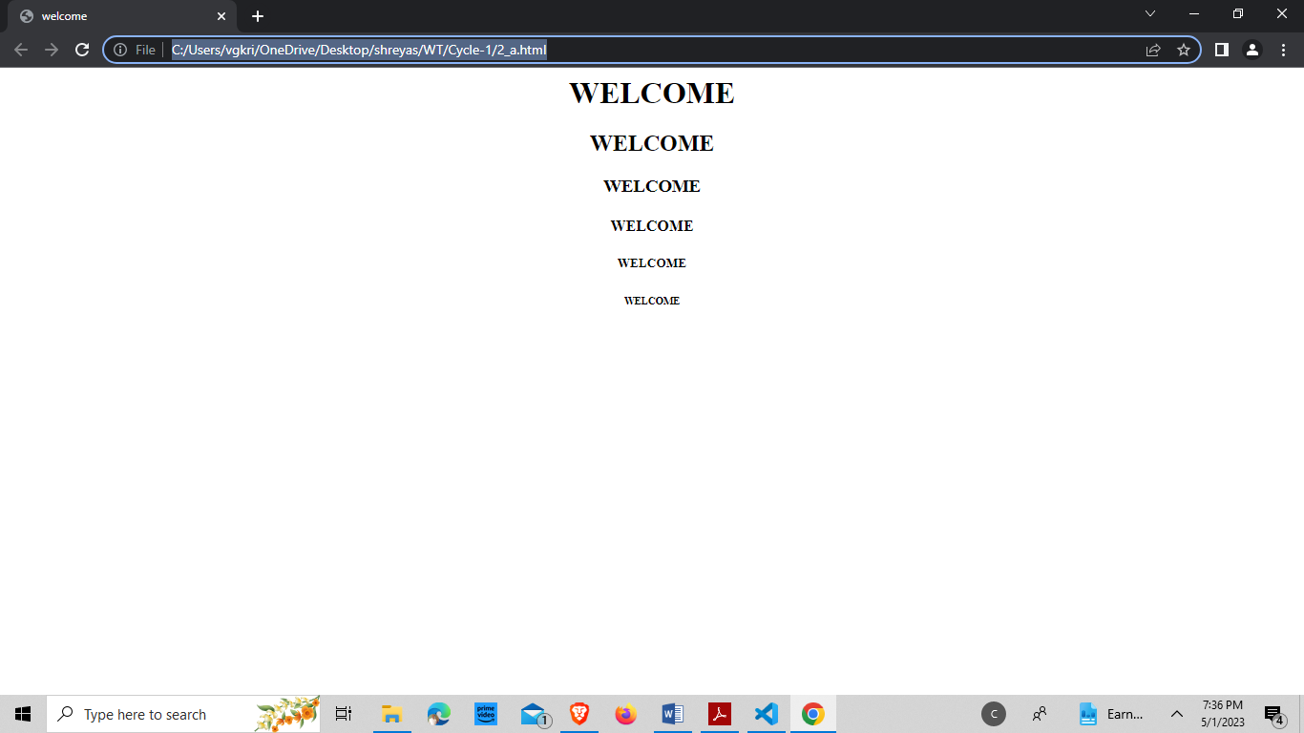

**2.**

1. **Create a web page which displays WELCOME text using heading tags(h1 to h6).**

**Source-Code:**

<html>

<head><title>welcome</title></head>

<body style="text-align: center;">

<h1>WELCOME</h1>

<h2>WELCOME</h2>

<h3>WELCOME</h3>

<h4>WELCOME</h4>

<h5>WELCOME</h5>

<h6>WELCOME</h6>

</body>

</html>

**Output:**

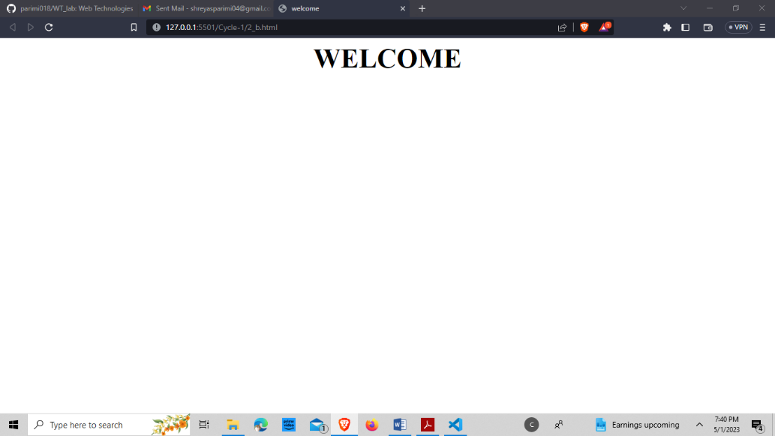

1. **Create a web page which displays WELCOME text using <b> tag.**

**Source-Code:**

<html>

<head><title>welcome</title></head>

<body>

<font size="300px">

<p><b><center>WELCOME</center></b></p>

</font>

</body>

</html>

**Output:**

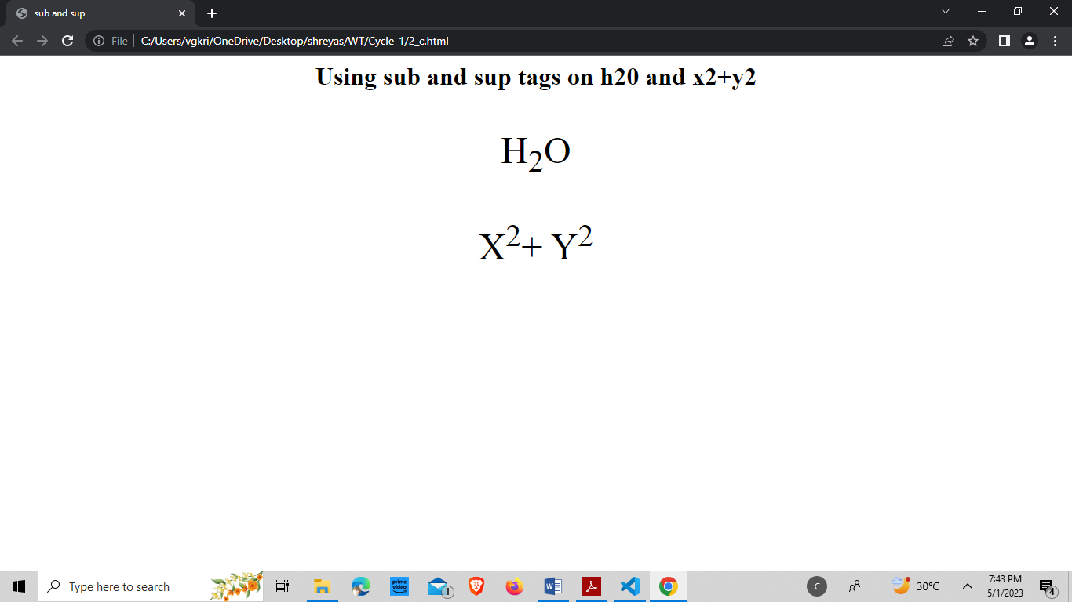

1. **Create a web page which displays h2o and x2+y2 using <sup> tag and <sub> tag.**

**Source-Code:**

<html>

<head><title>subandsup</title></head>

<body style="text-align: center;">

<h1>Using sub & sup tags </h1>

<font size="250px">

<p>H<sub>2</sub>O</p>

</font>

<font size="250px">

<p>X<sup>2</sup>+Y<sup>2</sup></p>

</font>

</body>

</html>

**Output:**

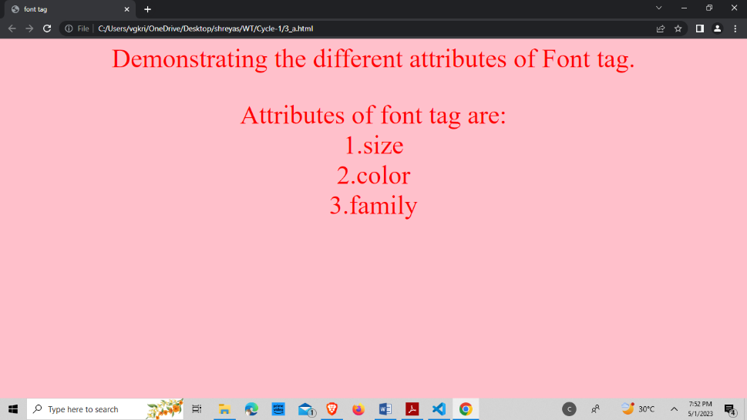

**3.**

1. **Create a web page to show different attributes of Font tag**

**Source-Code:**

<html>

<head>

<title>font tag</title>

</head>

<body bgcolor="pink" style="text-align: center;">

<h1>

Demonstrating the different attributes of Font tag.

</h1>

<font size="5"color="red" family="Arial">

<p>

Attributes of font tag are:<br>

1. size<br>
2. color<br>
3. family

</p>

</font>

</body>

</html>

**Output:**

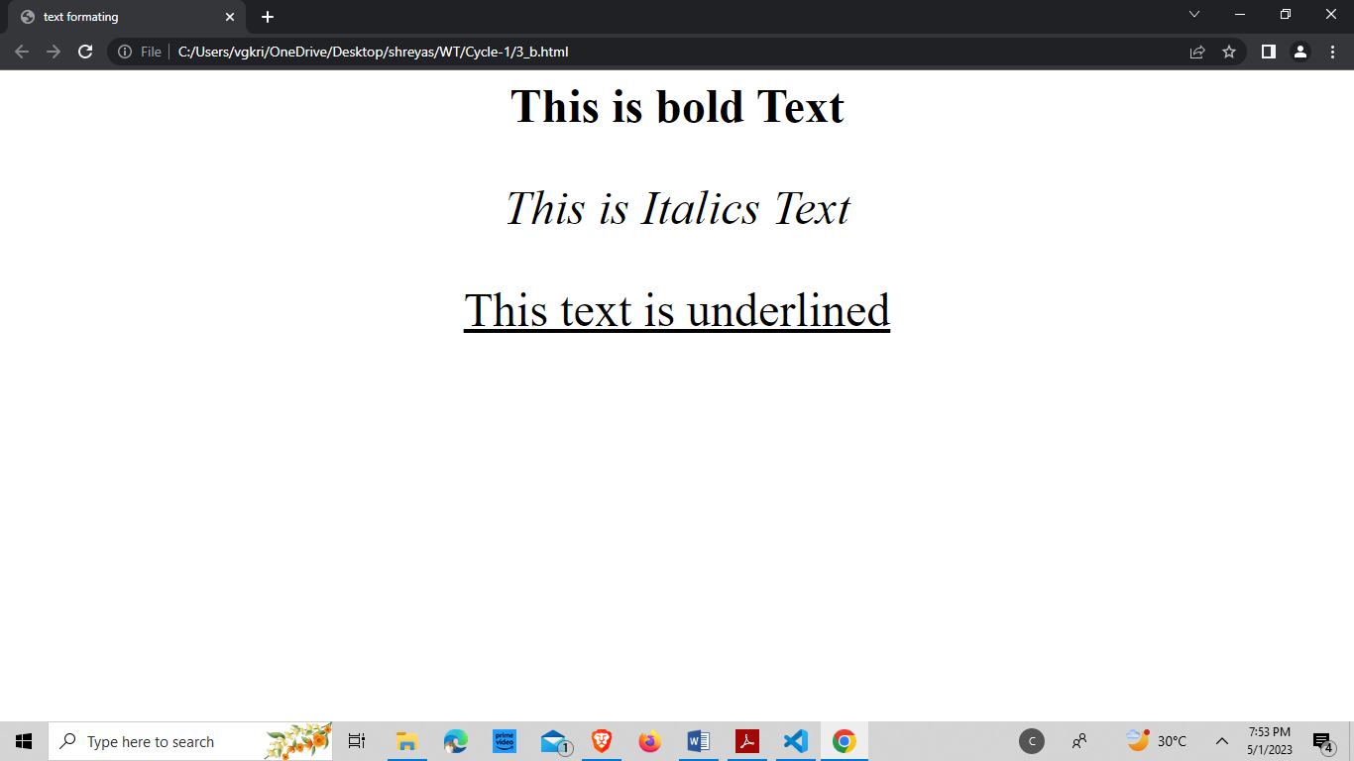

1. **Create a web page to show different attributes: italics, bold, underline.**

**Source-Code:**

<html>

<head>

<title>text formatting</title>

</head>

<body>

<font size="8">

<p><center><b>This is bold Text</b></center></p>

<p><center><i>This is Italics Text</i></center></p>

<p><center><u>This text is

underlined</u></center></p>

</font>

</body>

</html>

**Output:**

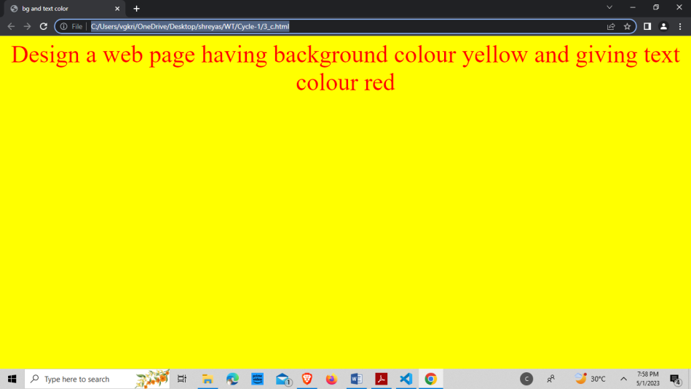

1. **Design a web page having background color yellow and giving text color red.**

**Source-Code:**

<html>

<head>

<title>bg and text color</title>

</head>

<body bgcolor="yellow">

<font color="red" size="8">

<p><center>Design a web page having background color yellow and giving text color red</center></p>

</font>

</body>

</html>

**Output:**

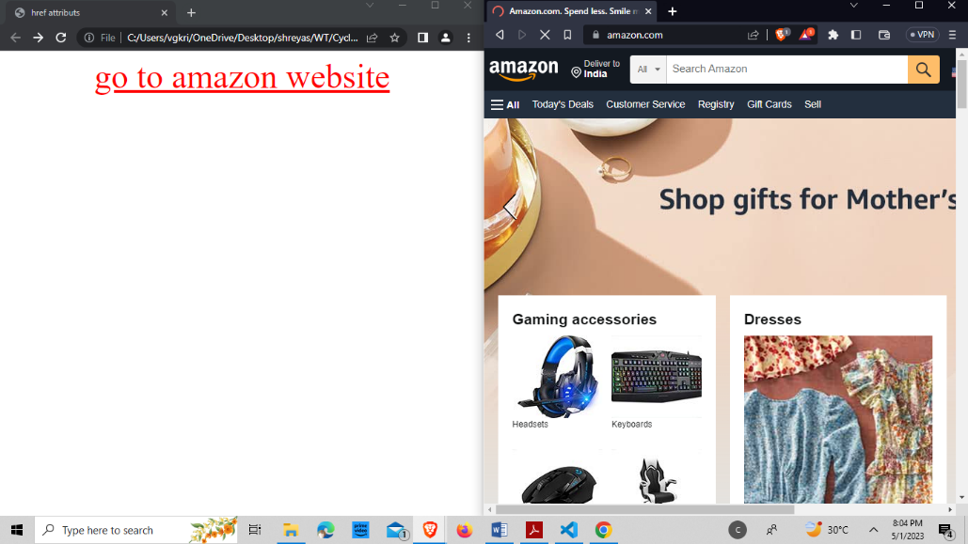

**4.**

1. **Create a web page using href attribute of anchor tag & the attribute: alink, vlink etc.**

**Source-Code:**

<html>

<head>

<title>href attributes</title>

</head>

<body vlink="red" align="center">

<font size="200px">

<ahref="https://www.amazon.in/?&ext_vrnc=hi&tag=googhydrabk1-21&ref=pd_sl_7hz2t19t5c_e&adgrpid=58355126069&hvpone=&hvptwo=&hvadid=61064460 1173&hvpos=&hvnetw=g&hvrand=12081366371491045350&hvqmt=e&hvdev=c&hvdvc mdl=&hvlocint=&hvlocphy=9147373&hvtargid=kwd-10573980&hydadcr=14453_23 16415">go to amazon website</a>

</font>

</body>

</html>

**Output:**

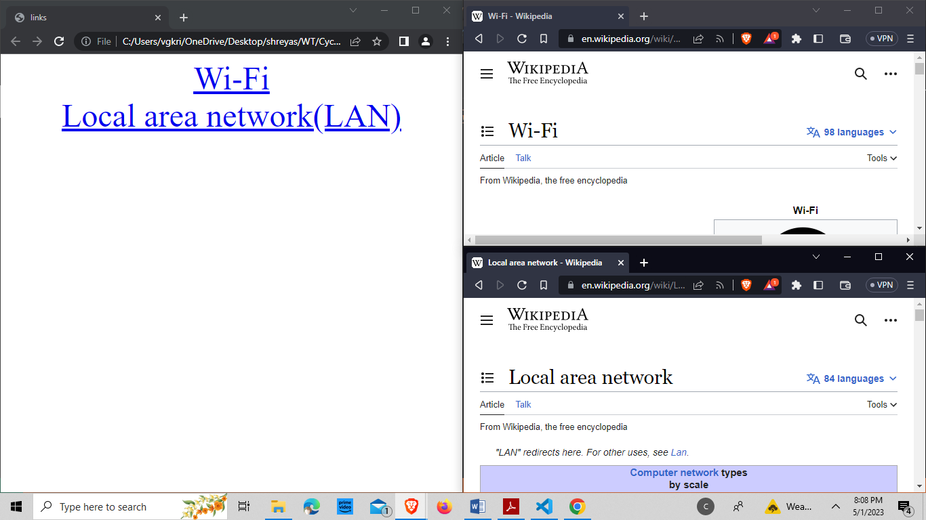

1. **Create links on the words e.g. ―Wi-Fi and ―LAN‖ to link them to Wikipedia pages.**

**Source-Code:**

<html>

<head>

<title>links</title>

</head>

<body align="center">

<font size="200px">

<ahref="https://en.wikipedia.org/

wiki/WiFi">-Fi</a><br>

<ahref="https://en.wikipedia.org/

wiki/Local_area_network">Local

area network(LAN)</a>

</font>

</body>

</html>

**Output:**

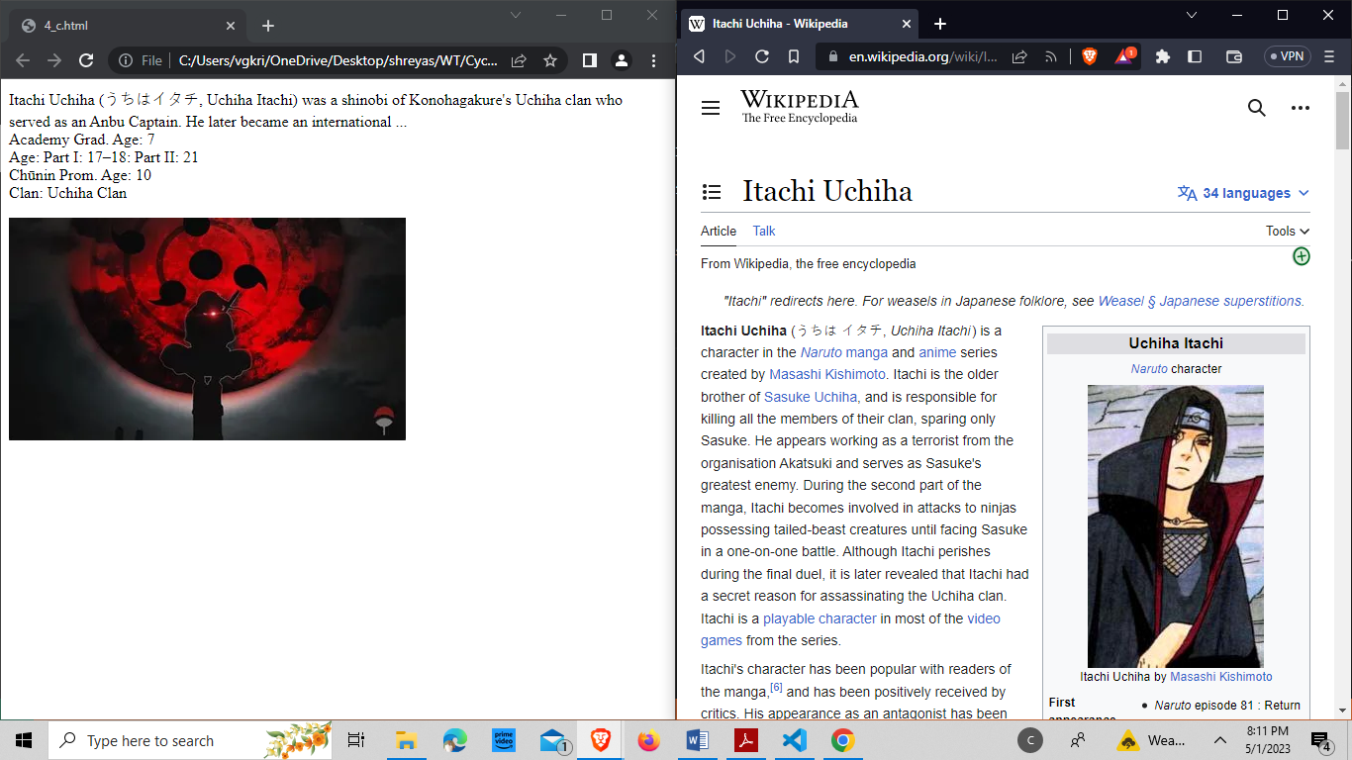

**c) Create a web page with appropriate content and insert an image towards the left hand side of the page. When user clicks on the image, it should open another Web page.**

**Source-Code:**

<html>

<head>

<title> </title>

</head>

<body>

<p>ItachiUchiha (うちはイタチ, UchihaItachi) was a shinobi of Konohagakure's Uchiha clan who served as an Anbu Captain. He later became an international ...

<br>Academy Grad. Age: 7

<br>Age: Part I: 17–18: Part II: 21

<br>Chūnin Prom. Age: 10

<br>Clan: Uchiha Clan</p>

<a href="https://en.wikipedia.org/wiki/

Itachi Uchiha">

<image align="left" src="itachi.jpg" alt="image not found">

</a>

</body>

</html>

**Output:**

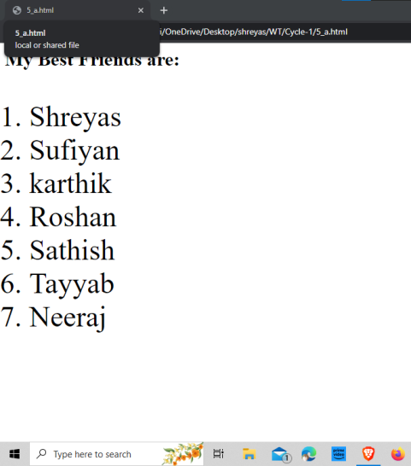

**5.**

**Create a web page, showing an ordered list of the names of five of your friends.**

**Source-Code:**

<html>

<head><title></title></head>

<body>

<h1>My Best Friends are:</h1>

<fontsize="180px">

<ol>

<li>Shreyas</li>

<li>Sufiyan</li>

<li>karthik</li>

<li>Roshan</li>

<li>Sathish</li>

<li>Tayyab</li>

<li>Neeraj</li>

</ol>

</font>

</body>

</html>

**Output:**

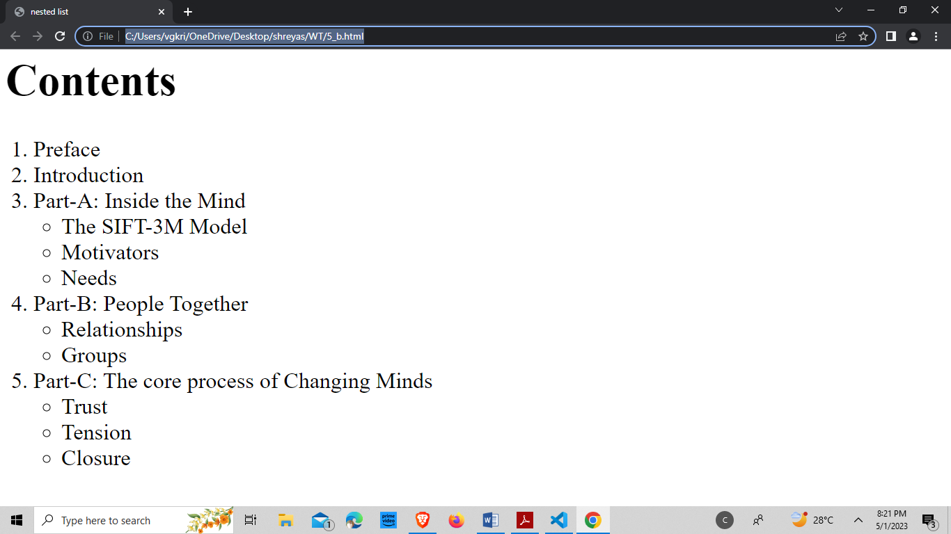

**Create a web page containing a nested list showing the content page of any book.**

**Source-Code:**

<html>

<head>

<title>nested list</title>

</head>

<body style="font-size: xx-large;">

<h1>Contents</h1>

<ol>

<li>Preface</li>

<li>Introduction</li>

<li>Part-A: Inside the Mind</li>

<ul>

<li>The SIFT-3M Model</li>

<li>Motivators</li>

<li>Needs</li>

</ul>

<li>Part-B: People Together</li>

<ul>

<li>Relationships</li>

<li>Groups</li>

</ul>

<li>Part-C: The core process of Changing Minds</li>

<ul>

<li>Trust</li>

<li>Tension</li>

<li>Closure</li>

</ul>

</ol>

</body>

</html>

**Output:**

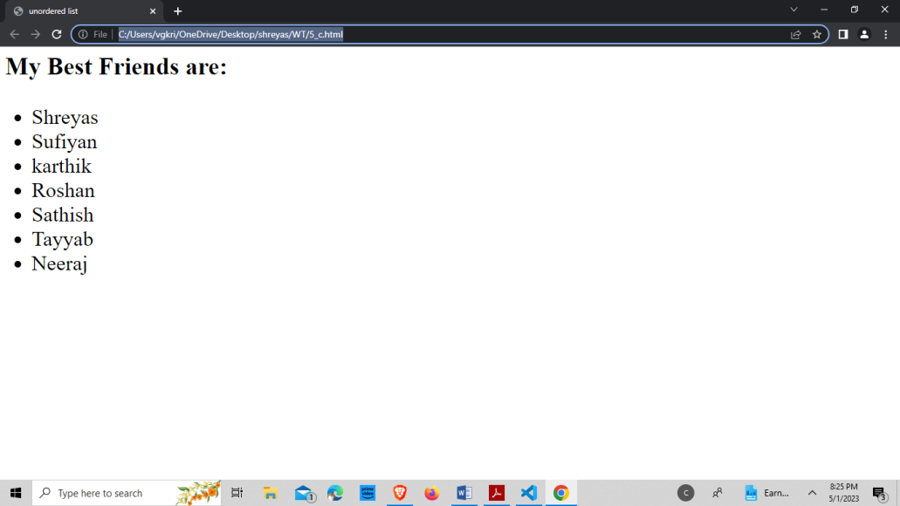

**Create a web page, showing an unordered list of names of five of your friends.**

**Source-Code:**

<html>

<head>

<title>unordered list</title>

</head>

<body style="font-size: xx-large;">

<h3>My Best Friends are:</h3>

<ul>

<li>Shreyas</li>

<li>Sufiyan</li>

<li>karthik</li>

<li>Roshan</li>

<li>Sathish</li>

<li>Tayyab</li>

<li>Neeraj</li>

</ul>

</body>

</html>

**Output:**

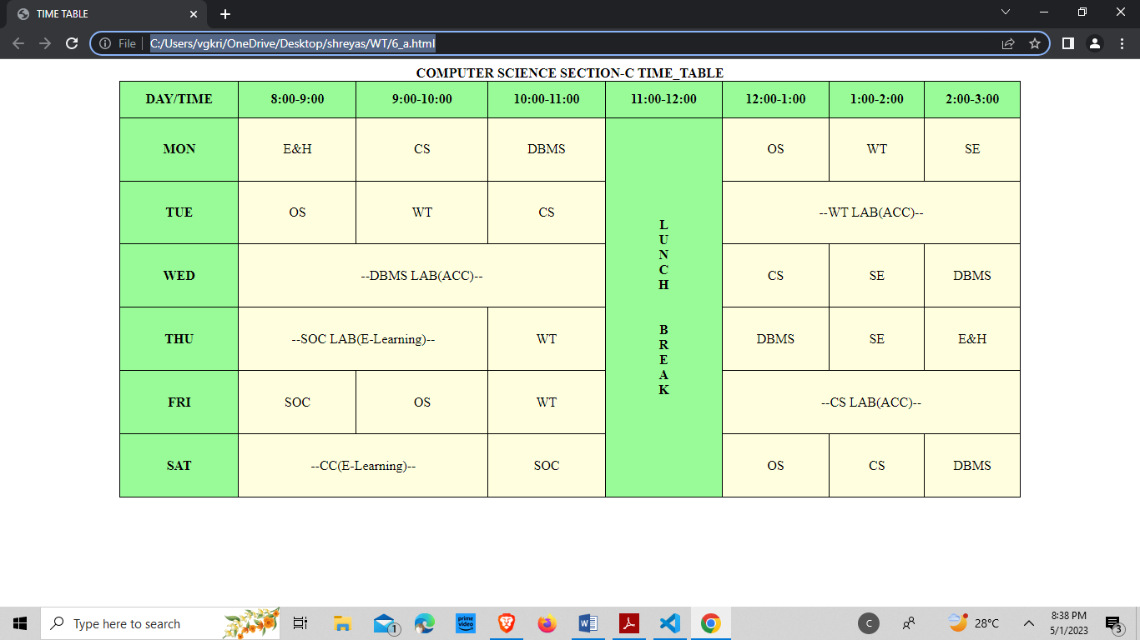

**6.**

**Create a table to show your class timetable using rowspan and colspan attributes.**

**Source-Code:**

<html>

<head><title>TIME TABLE</title>

<style>

table, tr, th, td {

border: 1pxsolidblack;

border-collapse: collapse;

}

th{

background-color:98FB98;

}

tr, td{

text-align: center;

background-color: FFFFE0;

}

table{

width:80%;

height:500px;

}

</style>

</head>

<body>

<table align="center" border="2">

<caption><b>COMPUTER SCIENCE SECTION-C TIME_TABLE</b></caption>

<tr align="center">

<th>DAY/TIME</th>

<th>8:00-9:00</th>

<th>9:00-10:00</th>

<th>10:00-11:00</th>

<th>11:00-12:00</th>

<th>12:00-1:00</th>

<th>1:00-2:00</th>

<th>2:00-3:00</th>

</tr>

<tr align="center">

<th>MON</th>

<td>E&H</td>

<td>CS</td>

<td>DBMS</td>

<th rowspan="6">L<br>

U<br>

N<br>

C<br>

H<br>

<br><br>

B<br>

R<br>

E<br>

A<br>

K<br></th>

<td>OS</td>

<td>WT</td>

<td>SE</td>

</tr>

<tr align="center">

<th>TUE</th>

<td>OS</td>

<td>WT</td>

<td>CS</td>

<td colspan="3">--WT LAB(ACC)--</td>

</tr>

<tr align="center">

<th>WED</th>

<td colspan="3">--DBMS LAB(ACC)--</td>

<td>CS</td>

<td>SE</td>

<td>DBMS</td>

</tr>

<tr align="center">

<th>THU</th>

<td colspan="2">--SOC LAB(E-Learning)--</td>

<td>WT</td>

<td>DBMS</td>

<td>SE</td>

<td>E&H</td>

</tr>

<tr align="center">

<th>FRI</th>

<td>SOC</td>

<td>OS</td>

<td>WT</td>

<td colspan="3">--CS LAB(ACC)--</td>

</tr>

<tr align="center">

<th>SAT</th>

<td colspan="2">--CC(E-Learning)--</td>

<td>SOC</td>

<td>OS</td>

<td>CS</td>

<td>DBMS</td>

</tr>

</table>

</body>

</html>

**Output:**

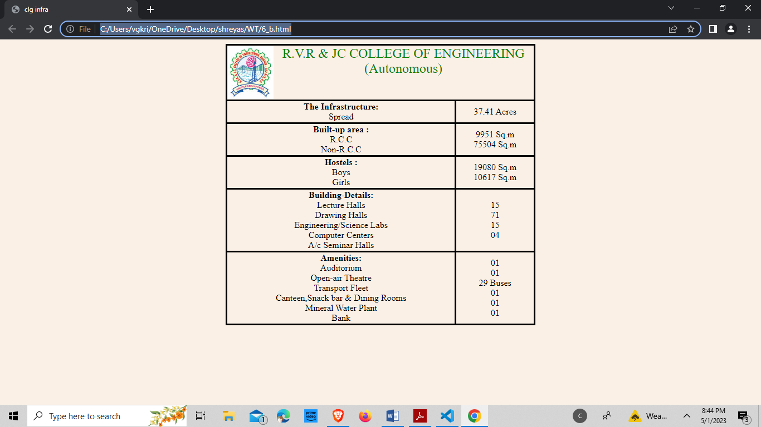

1. **Use tables to provide layout to your HTML page describing your college infrastructure**

**Source-Code:**

<html>

<head><title>clg infra</title></head>

<body bgcolor="linen">

<table style="border-collapse: collapse; border: solid;height:40%;"align="Center">

<tr align="Center">

<td colspan="2"style="border:

solid; text-align: center;">

<img src="C:\Users\vgkri\One

Drive\Desktop\shreyas\WT\

Cycle-1\rvrjc.jpeg" alt="no image" style="float: left; width:15%;">

<fontcolor="green"size="5">R.V.R & JC COLLEGE OF ENGINEERING <br>(Autonomous)

</font>

</td>

</tr>

<tr style="border: solid" align="Center">

<td style="border: solid"><b>The Infrastructure:</b><br>Spread</td>

<td style="border: solid">37.41 Acres</td>

</tr>

<tr style="border: solid" align="Center">

<td style="border: solid">

<b>Built-up area :</b><br>

R.C.C <br>

Non-R.C.C

</td>

<td style="border: solid">9951 Sq.m<br>75504 Sq.m</td>

</tr>

<tr style="border: solid" align="Center">

<td style="border: solid">

<b>Hostels :</b><br>

Boys <br>Girls

</td>

<td style="border: solid">19080 Sq.m<br>10617 Sq.m</td>

</tr>

<tr style="border: solid" align="Center">

<td style="border: solid">

<b>Building-Details:</b>

<br>Lecture Halls

<br>Drawing Halls</td>

<td style="border:solid"94<br>15 <br>71 <br>15 <br>04</td>

</tr>

<tr style="border: solid" align="Center">

<td style="border: solid">

<b>Amenities:</b>

<br>Auditorium

<br>Open-air Theatre

<br>Transport Fleet

<br>Canteen, Snack bar & Dining Rooms

<br>Mineral Water Plant

<br>Bank

</td>

<td style="border: solid">

01

<br>01

<br>29 Buses

<br>01

<br>01

<br>01

</td>

</tr>

</table>

</body>

</html>

**Output:**

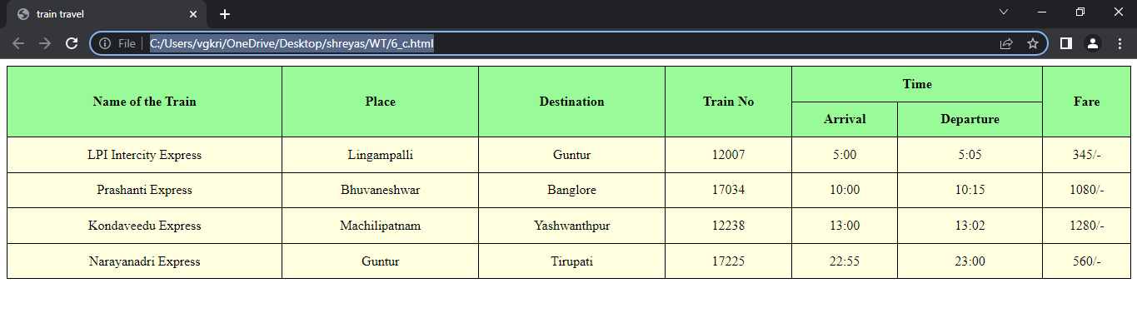

**Create a web page in the following table fields**

|  |  |  |  |  |  |
| --- | --- | --- | --- | --- | --- |
| **Name of Train** | **Place** | **Destination** | **Train no** | **Time** | **Fare** |
|  |  |  |  |  |  |

**Source-Code:**

<html>

<head><title>train travel</title>

<style>

table, tr, th, td {

border: 1pxsolidblack;

border-collapse: collapse;

}

th{

background-color:98FB98;

}

tr,td{

text-align: center;

background-color:FFFFE0;

}

table{

width:80%;

height:500px;

}

</style>

</head>

<body>

<table border="2"align="center" style="border-collapse: collapse; width: 100%; height:40%">

<tr align="center">

<th rowspan="2">Name of the Train</th>

<th rowspan="2">Place</th>

<th rowspan="2">Destination</th>

<th rowspan="2"> Train No</th>

<th colspan="2">Time</th>

<th rowspan="2">Fare</th>

</tr>

<tr align="center">

<th>Arrival</th>

<th>Departure</th>

</tr>

<tr align="center">

<td>LPI Intercity Express</td>

<td>Lingampalli</td>

<td>Guntur</td>

<td>12007</td>

<td>5:00</td>

<td>5:05</td>

<td>345/-</td>

</tr>

<tr align="center">

<td>Prashanti Express</td>

<td>Bhuvaneshwar</td>

<td>Banglore</td>

<td>17034</td>

<td>10:00</td>

<td>10:15</td>

<td>1080/-</td>

</tr>

<tr align="center">

<td>Kondaveedu Express</td>

<td>Machilipatnam</td>

<td>Yashwanthpur</td>

<td>12238</td>

<td>13:00</td>

<td>13:02</td>

<td>1280/-</td>

</tr>

<tr align="center">

<td>Narayanadri Express</td>

<td>Guntur</td>

<td>Tirupati</td>

<td>17225</td>

<td>22:55</td>

<td>23:00</td>

<td>560/-</td>

</tr>

</table>

</body>

</html>

**Output:**

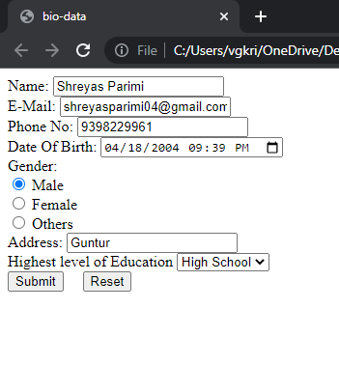

**7.**

1. **Create your bio-data form on a web page using all input types**

**Source-Code:**

<html>

<head><title>bio-data</title></head>

<body>

<form>

<label for="n">Name:</label>

<input type="text" name="n" id="name" required>

<br>

<label for="e">E-Mail:</label>

<input type="email" name="e" id="email" required>

<br>

<label for="pn">Phone No:</label>

<input type="tel" name="pn" id="phonen" required>

<br>

<label for="db">Date Of Birth:</label>

<input type="datetime-local" name="db" id="dob" required>

<br>

<label for="g">Gender:</label>

<br>

<input type="radio" name="m" id="ma" required>

<label for="m">Male</label>

<br>

<input type="radio" name="m" id="fe" required>

<label for="m">Female</label>

<br>

<input type="radio" name="m" id="ot" required>

<label for="m">Others</label>

<br>

<label for="a">Address:</label>

<input type="text" name="a" id="address" required>

<br>

<label for="edu">Highest level of Education</label>

<select name="edu" id="educ">

<option value="phd">PHD</option>

<optionvalue="m">Masters</option>

<option value="b">Bachelors</option>

<option value="h">High School</option>

</select>

<br>

<input type="submit">

&nbsp; &nbsp;

<input type="reset">

</form>

</body>

</html>

**Output:**

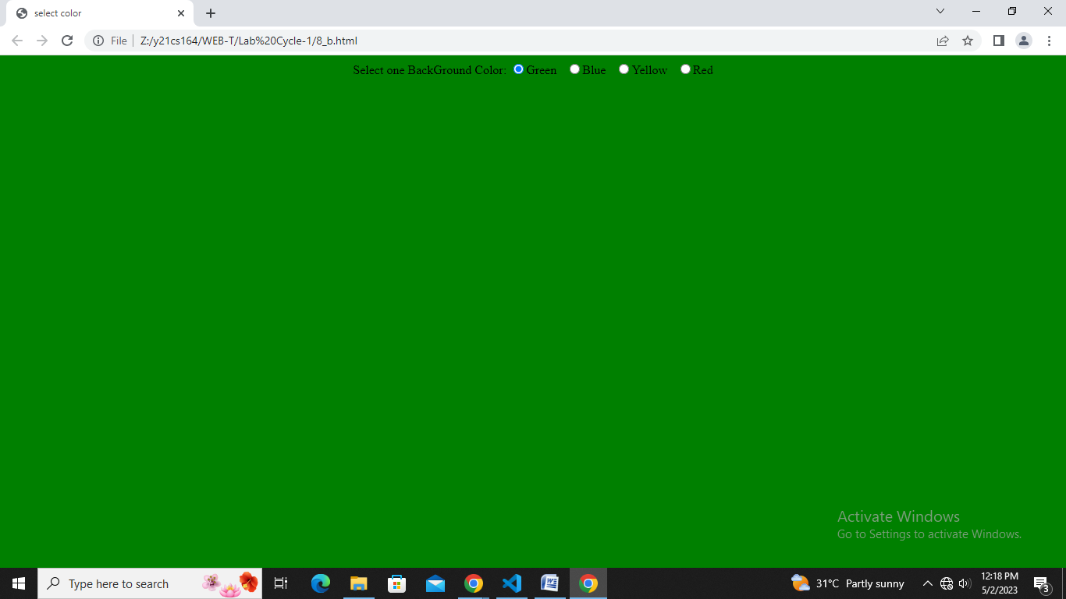

1. **Create a web page having radio buttons labeled as name of colors. Clicking on each radio button should change the color of the Web page**

**Source-Code:**

<html>

<head><title>select color</title></head>

<body align="center">

<label for="c">Select one:</label>

<input type="radio" name="g" onclick="document.bgColor='Green'">Green &nbsp;

<input type="radio" name="b" onclick="document.bgColor='Blue'">Blue &nbsp;

<input type="radio" name="y" onclick="document.bgColor='Yellow'">Yellow

&nbsp;

<input type="radio" name="r" onclick="document.bgColor='Red'">Red

</body>

</html>

**Output:**

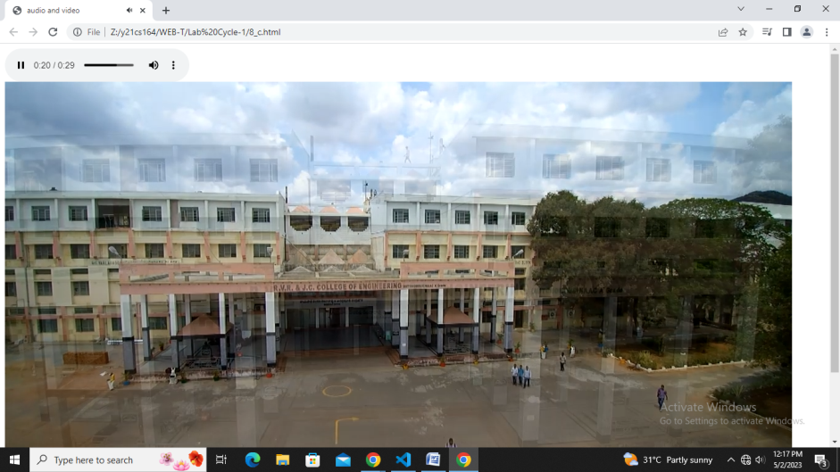

1. **Embed Audio and Video into your web page**

**Source-Code:**

<html>

<head><title>audio and video</title></head>

<body>

<audio src="itachi.mp3" controls></audio>

<video src="avclg.mp4" autoplay muted></video>

</body>

</html>

**Output:**

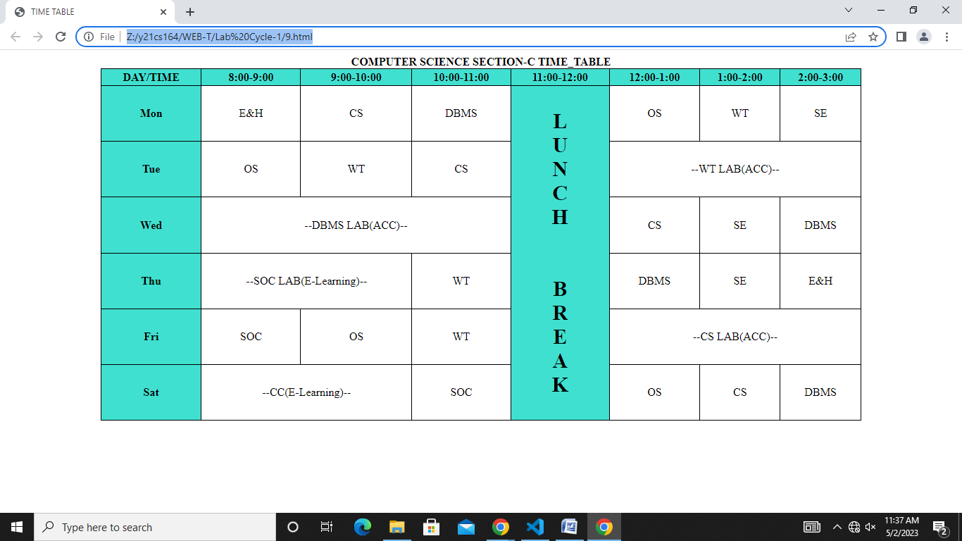

**8.**

1. **Create a webpage which displays the class time table and apply the following effects on the table: For the table header apply blue as the background color and white for the color of the text in the table header.**
2. **Display days in a week (Mon, Tue etc...) in bold format with the first letter in the day name in uppercase.**
3. **Display lunch slightly in bigger font other than the remaining text.**

**Code:**

<html>

<head><title>TIME TABLE</title>

<style>

table, tr,th, td {

border: 1px solid black;

border-collapse: collapse;

}

th{

background-color:#40E0D0;

}

tr,td{

text-align:center;

background-color:white;

}

table{

width:80%;

height:500px;

}

#tayyab{

font-size: 30;

}

</style>

</head>

<body>

<table align="center" border="2" >

<caption><b>COMPUTER SCIENCE SECTION-C TIME_TABLE</b></caption>

<tr align="center">

<th>DAY/TIME</th>

<th>8:00-9:00</th>

<th>9:00-10:00</th>

<th>10:00-11:00</th>

<th>11:00-12:00</th>

<th>12:00-1:00</th>

<th>1:00-2:00</th>

<th>2:00-3:00</th>

</tr>

<tr align="center">

<th>Mon</th>

<td>E&H</td>

<td>CS</td>

<td>DBMS</td>

<th id="tayyab" rowspan="6">L<br>

U<br>

N<br>

C<br>

H<br>

<br><br>

B<br>

R<br>

E<br>

A<br>

K<br></th>

<td>OS</td>

<td>WT</td>

<td>SE</td>

</tr>

<tr align="center">

<th>Tue</th>

<td>OS</td>

<td>WT</td>

<td>CS</td>

<td colspan="3">--WT LAB(ACC)--</td>

</tr>

<tr align="center">

<th>Wed</th>

<td colspan="3">--DBMS LAB(ACC)--</td>

<td>CS</td>

<td>SE</td>

<td>DBMS</td>

</tr>

<tr align="center">

<th>Thu</th>

<td colspan="2">--SOC LAB(E-Learning)--</td>

<td>WT</td>

<td>DBMS</td>

<td>SE</td>

<td>E&H</td>

</tr>

<tr align="center">

<th>Fri</th>

<td>SOC</td>

<td>OS</td>

<td>WT</td>

<td colspan="3">--CS LAB(ACC)--</td>

</tr>

<tr align="center">

<th>Sat</th>

<td colspan="2">--CC(E-Learning)--</td>

<td>SOC</td>

<td>OS</td>

<td>CS</td>

<td>DBMS</td>

</tr>

</table>

</body>

</html>

**Output:**

**Inline:**

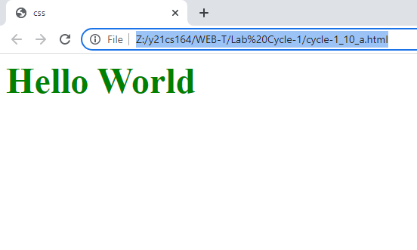

**Embedded:**

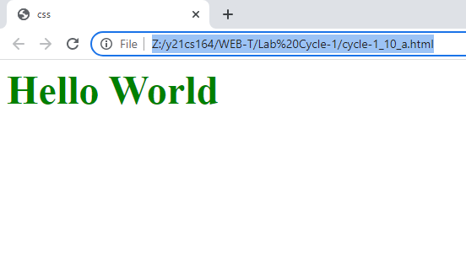

**External:**



**9.**

1. **Create a webpage which displays "Hello World" with font size 20 pixels, bold format, in "Times New Roman" font and green in color using inline CSS, embedded CSS and external CSS.**

**i)Inline:**

**Source-code:**

<html>

<head><title>css</title></head>

<body>

<font size="20px" face="Times New Roman" color="green">

<strong> Hello World</strong>

</font>

</body>

</html>

**ii)Embedded:**

**Source-Code:**

<html>

<head>

<title>css</title>

<style>

p{

font-size:80px;

font-family: "Times new roman";

color: green;

font-weight: bold;

}

</style>

</head>

<body>

<p>Hello World</p>

</body>

</html>

**iii)External:**

**Source-Code:**

**//html file:**

<html>

<head>

<title>css</title>

<link rel="stylesheet" type="text/css" href="style1.css">

</link>

</head>

<body>

<p>Hello World</p>

</body>

</html>

**//css file:**

p{

font-size:80px;

font-family: "Times new roman";

color: green;

font-weight: bold;

}

**Output:**

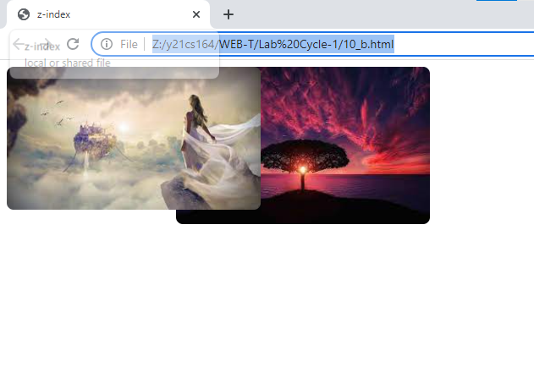

1. **Create a web page containing two images, where one image overlaps another image by using the z-index CSS property.**

**Source-Code:**

<html>

<head><title>z-index</title>

<style>

.cont{

position: relative;

}

img{

position: absolute;

}

#st{

width:300px;

margin-left:200px;

z-index:1;

border-radius: 8px;

}

#nd{

width:300px;

z-index:2;

border-radius: 8px;

}

</style>

<body>

<div class="cont">

<img id="st" src="1.jpg" alt="image not found">

<img id="nd" src="2.jpg" alt="image not found">

</div>

</body>

</html>

**Output:**

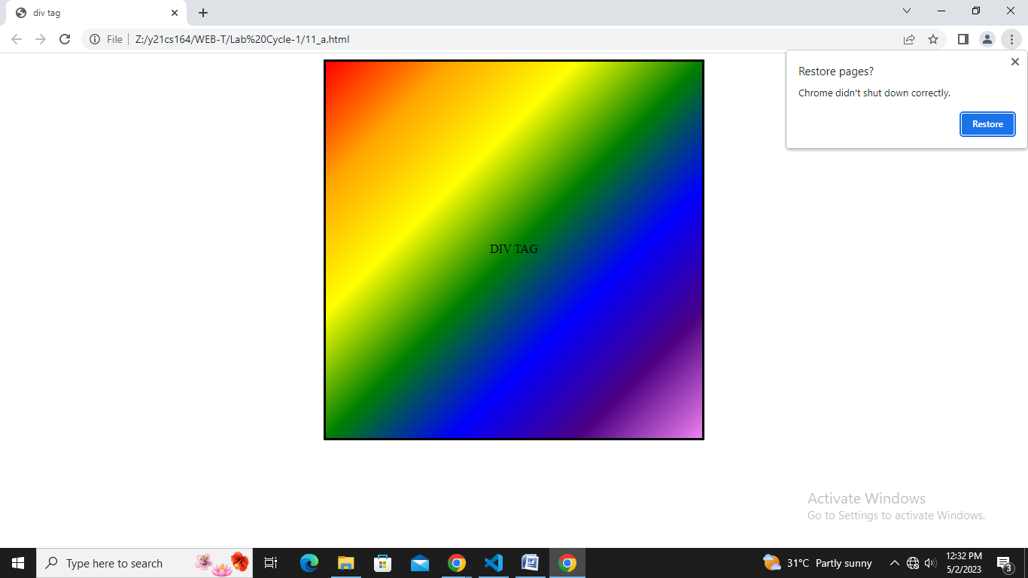

**10.**

**a) Create a div element with a width and height of 500px. Create a diagonal linear gradient using the colors of the rainbow—Red, Orange, Yellow, Green, Blue, Indigo, Violet. (Linear Gradient).**

**Source-Code:**

<html>

<head>

<title>div tag</title>

<style>

div{

text-align: center ;

border: 3px solid black;

margin: auto;

padding: auto;

width:500px;

height:500px;

background: linear-gradient(to right bottom, Red, Orange, Yellow, Green, Blue, Indigo, Violet)

}

p{

margin-top: 240px;

}

</style>

</head>

<body>

<div><p>DIV TAG</p></div>

</body>

</html>

**Output:**

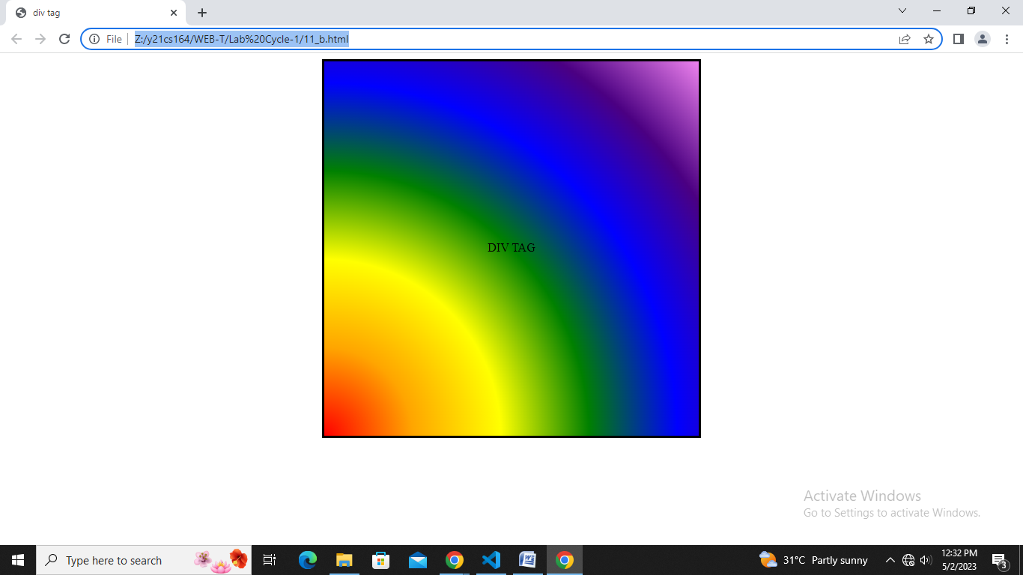

**b) Create a div element with a width and height of 500px. Create a radial gradient with three colors. Start the gradient in the bottom-left corner with the colors changing as they move along the gradient line to the right. (Radial Gradient)**

**Source-Code:**

<html>

<head>

<title>div tag</title>

<style>

div{

text-align: center ;

border: 3px solid black;

margin: auto;

padding: auto;

width:500px;

height:500px;

background: radial-gradient(circle at bottom left , Red, Orange, Yellow, Green, Blue, Indigo, Violet)

}

p{

margin-top: 240px;

}

</style>

</head>

<body>

<div><p>DIV TAG</p></div>

</body>

</html>

**Output:**

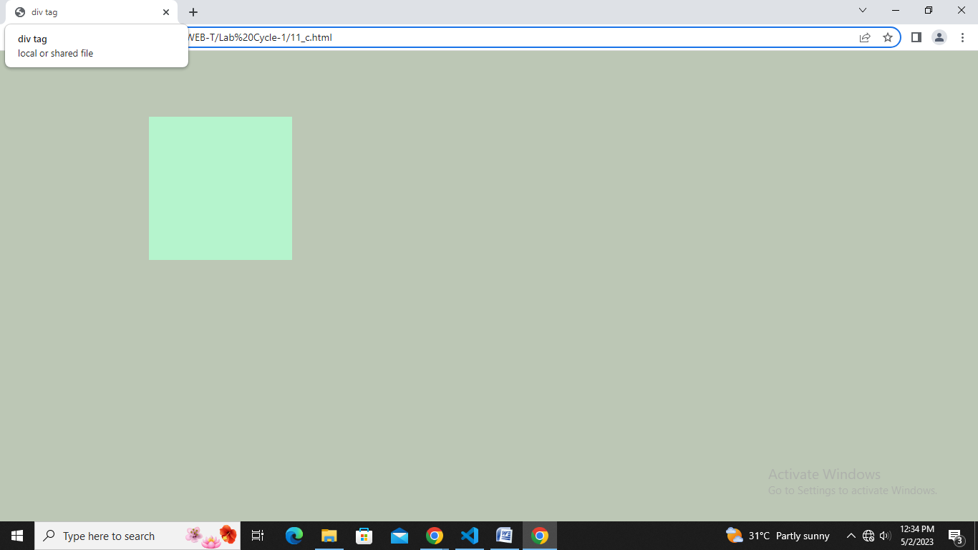

**c)**

**Create an infinite animation of an element moving in a square pattern. (Animation)**

**Source-Code:**

<html>

<head>

<title>div tag</title>

<style>

div{

position: relative;

width:200px;

height:200px;

animation: square 1s linear infinite;

background-color: aqua;

}

body{

animation: bg 1s linear infinite;

}

@keyframes bg{

0%{

background-color: aquamarine;

}

25%{

background-color: bisque;

}

50%{

background-color: cadetblue;

}

75%{

background-color: turquoise;

}

100%{

background-color: antiquewhite;

}

}

@keyframes square{

0%

{

background-color: antiquewhite;

left:0px;

top:0px;

}

25%

{

background-color: aquamarine;

left:200px;

top:0px;

}

50%

{

background-color: bisque;

left:200px;

top:200px;

}

75%

{

background-color: cadetblue;

left:0px;

top:200px;

}

100%

{

background-color: turquoise;

left:0px;

top:0px;

}

}

</style>

</head>

<body>

<div></div>

</body>

</html>